Project Design Phase-II - Data Flow Diagrams & User Stories
Date | 12 August 2026
Team ID | N/A
Author / Team Member | Ruturaj Misal
Project Name | ShopEZ Ecommerce Application
Maximum Marks | 4 Marks

Data Flow Overview (DFD Levels) - Lead: Ruturaj Misal
• DFD Level 0 (Context Diagram): External Entities (Shopper, Merchant, Administrator) exchange credentials, queries, and orders with the central ShopEZ Web Platform.
• DFD Level 1: Subsystems: 1.0 Auth, 2.0 Catalog & Search, 3.0 Cart & Price Calc, 4.0 Checkout & Order, 5.0 Seller & Admin Operations.
• DFD Level 2: Detailed Order Checkout Pipeline Flow.
Visual Data Flow Diagram (DFD Levels 0, 1 & 2):

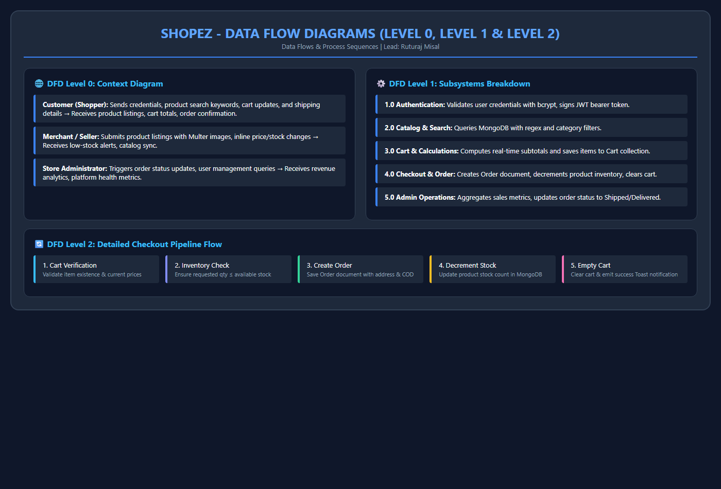
Figure 6: Data Flow Diagrams for ShopEZ E-Commerce Subsystems

User Role | Epic | Story ID | User Story Description | Acceptance Criteria | Story Points
Shopper | Auth | USN-01 | As a new user, I want to register with my name, email, and password. | Validates email format, minimum 6 character password, hashes password, returns JWT. | 5
Shopper | Auth | USN-02 | As a registered user, I want to log in and stay authenticated across sessions. | Returns JWT token, stores user in AuthContext & localStorage, redirects to landing. | 3
Shopper | Catalog | USN-03 | As a shopper, I want to browse products with search and category filters. | Filtering by category, search by product name/description, real-time results. | 5
Shopper | Cart | USN-06 | As a shopper, I want to add items to my shopping cart. | Updates cart item count in navbar, recalculates total amount on the fly. | 3
Shopper | Checkout | USN-08 | As a shopper, I want to place an order with my shipping address and COD. | Validates address fields, creates Order document, clears cart, redirects to profile. | 5
Seller | Inventory | USN-10 | As a seller, I want to view all inventory on `/admin/sell` with inline editing. | Directly edit price and stock values in table cells with auto-save to MongoDB. | 5
Seller | Inventory | USN-11 | As a seller, I want warning alerts when products have less than 10 units left. | Displays prominent warning badge when item stock is low. | 3
Admin | Governance | USN-13 | As an admin, I want to view platform analytics (revenue, total orders, users). | Fetches aggregations from `/api/admin/dashboard` and renders metrics cards. | 5

